**ASSIGNMENT NO.9.**

**Aim :-** Company maintains employee information as employee ID, name, designation and salary. Allow user to add, delete information of employee. Display information of particular employee. If employee does not exist an appropriate message is displayed. If it is, then the system displays the employee details. Use index sequential file to maintain the data.

**Objective:-** to study use of different data structure concepts in this program.

**Theory:-**

**Input/output formatting**

Writing to or reading from a file is similar to writing onto a terminal screen or reading from a keyboard. Differences are:

* File must be opened with an OPEN statement, in which the unit number and (optionally) the filename are given
* Subsequent writes (or reads) must refer to a known unit number (used for open)
* File should be closed at the end

**File opening and closing**

The syntax is:

OPEN([unit=]lunit,file='name' [,options])

CLOSE([unit=]lunit [,options])

For example:

OPEN(10, file='output.dat', status='new')

CLOSE(unit=10)

* The first parameter is the unit number and the keyword unit= can be omitted.
* The unit numbers 0,5 and 6 are predefined.
  + 0 is output for standard (system) error messages
  + 5 is for standard (user) input
  + 6 is for standard (user) output
  + These units are opened by default and should not be re-opened nor closed by users

Some options for opening a file:

* + status: existence of the file ('old', 'new', 'replace', 'scratch', 'unknown')
  + position: offset, where to start writing ('append')
  + action: file operation mode ('write','read','readwrite')
  + form: text or binary file ('formatted', 'unformatted')
  + access: direct or sequential file access ('direct','sequential','stream')
  + iostat: error indicator, (output) integer (non zero only upon an error)
  + err: the label number to jump upon error
  + recl: record length, (input) integer for direct access files only. Be careful, it can be in bytes or words...

**Algorithm:-**

**Program Code:-**

#include <iostream>

#include <fstream>

#include <cstring>

#include <iomanip>

#include<cstdlib>

#define max 50

using namespace std;

class Employee

{

char name[max];

int empid;

int sal;

char de[50];

friend class FileOperations;

public: Employee()

{

strcpy(name,"");

empid=sal==0;

strcpy(de,"");

}

Employee(char name[max],int empid,int sal,char de[max])

{

strcpy(this->de,de);

strcpy(this->name,name);

this->empid=empid;

this->sal=sal;

}

int getEmpId()

{

return empid;

}

void displayEmployeeData()

{

cout<<endl<<empid<<"\t\t\t"<<name<<"\t\t\t"<<sal<<"\t\t\t"<<de;

}

};

class FileOperations

{

fstream file;

public:FileOperations(char *name)

{

//strcpy(this->name,name);

this->file.open(name,ios::in|ios::out|ios::ate|ios::binary);

}

void insertRecord(int empid,char name[max],int sal,char de[max])

{

Employee s=Employee(name,empid,sal,de);

file.seekp(0,ios::end);

file.write((char*)&s,sizeof(Employee));

file.clear();

}

void displayAllRecords()

{

Employee s;

file.seekg(0,ios::beg);

while(file.read((char *)&s,sizeof(Employee)))

{

s.displayEmployeeData();

}

file.clear();

}

void displayRecord(int empid)

{

Employee s;

file.seekg(0,ios::beg);

void *p;

while(file.read((char *)&s,sizeof(Employee)))

{

if(s.empid==empid)

{

s.displayEmployeeData();

break;

}

}

if(p==NULL)

throw "Element not present";

file.clear();

}

void deleteRecord(int empid)

{

ofstream newFile("new.txt",ios::binary);

file.seekg(0,ios::beg);

bool flag=false;

Employee s;

while(file.read((char *)&s,sizeof(s)))

{

if(s.empid==empid)

{

flag=true;

continue;

}

newFile.write((char *)&s,sizeof(s));

}

if(!flag)

{

cout<<"Element Not Present";

}

file.close();

newFile.close();

remove("Employee.txt");

rename("new.txt","Employee.txt");

file.open("Employee.txt",ios::in|ios::ate|ios::out|ios::binary);

}

~FileOperations()

{

file.close();

cout<<"Closing file..";

}

};

int main()

{

ofstream newFile("Employee.txt",ios::app|ios::binary);

newFile.close();

FileOperations file((char *)"Employee.txt");

int empid,sal,choice=0;

char name[max],de[max];

while(choice!=5)

{

cout<<"\n\n1) Add New Record\n";

cout<<"2) Display All Records\n";

cout<<"3) Display by RollNo\n";

cout<<"4) Deleting a Record\n";

cout<<"5) Exit\n";

cout<<"Choose your choice : ";

cin>>choice;

switch(choice)

{

case 1 : //New Record

cout<<endl<<"Enter employee id and name : \n";

cin>>empid>>name;

cout<<"Enter sal \n";

cin>>sal;

cout<<"Enter designation : \n";

cin>>de;

file.insertRecord(empid,name,sal,de);

break;

case 2 :

cout<<"Employee ID"<<"\t\t"<<"Name"<<"\t\t"<<"Salary"<<"\t\t"<<"designation\n";

cout<<"----------------------------------------------------------------------";

file.displayAllRecords();

break;

case 3 :

cout<<"Enter employee id";

cin>>empid;

try

{

file.displayRecord(empid);

}

catch(const char *str)

{

cout<<str;

}

break;

case 4:

cout<<"Enter employe id";

cin>>empid;

file.deleteRecord(empid);

break;

case 5 :break;

}

}

}

**Output Screenshots:-**

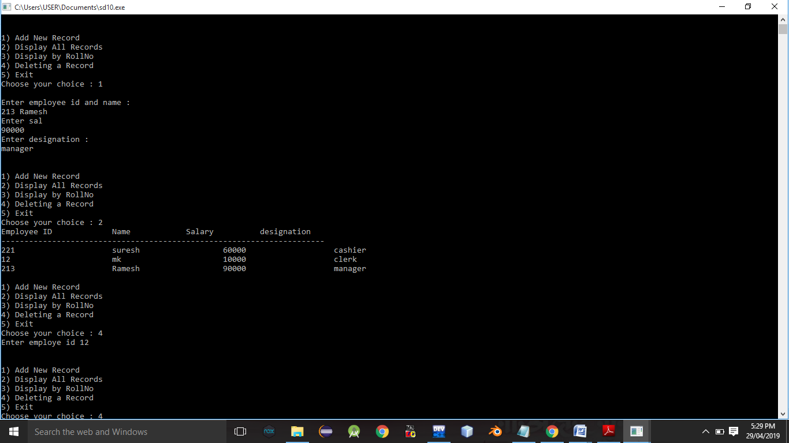

**Conclusion:-** Thus, this assignment is completed successfully.